Name __________________________________________________________ Hour_________

**12.7 Word Problems**

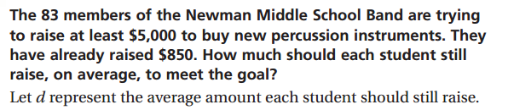

Inequality_________________________________ Solution set________________________________

Answer phrase______________________________

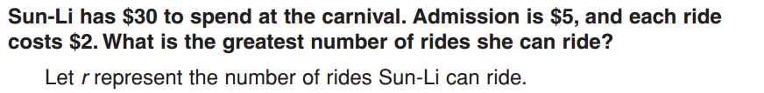

Inequality_________________________________ Solution set________________________________

Answer phrase______________________________

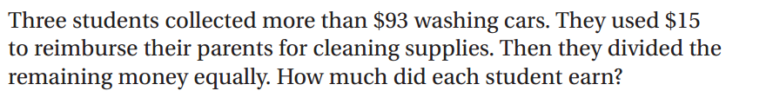variable _________________________________  
   
Inequality_________________________________ Solution set________________________________

Answer phrase______________________________

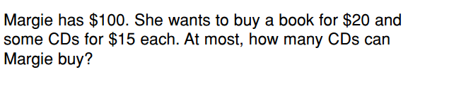

variable _________________________________

Inequality_________________________________ Solution set________________________________

Answer phrase______________________________

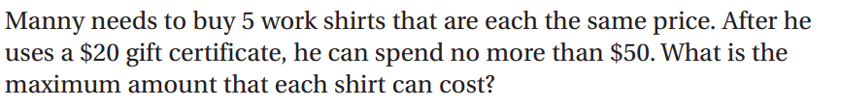

variable _________________________________   
  
Inequality_________________________________ Solution set________________________________

Answer phrase______________________________

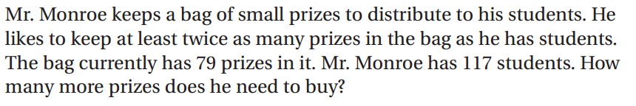variable _________________________________   
  
Inequality_________________________________ Solution set________________________________

Answer phrase______________________________

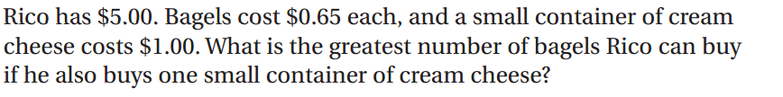variable _________________________________   
  
Inequality_________________________________ Solution set________________________________

Answer phrase______________________________

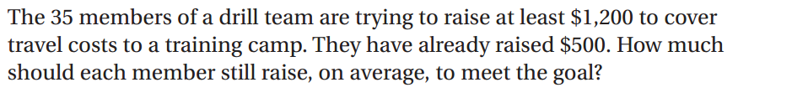variable _________________________________   
  
Inequality_________________________________ Solution set________________________________

Answer phrase______________________________

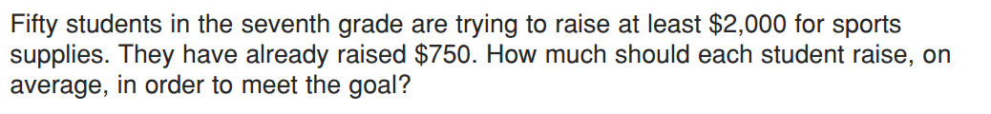variable _________________________________   
  
Inequality_________________________________ Solution set________________________________

Answer phrase______________________________

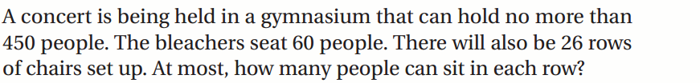

variable _________________________________   
  
Inequality_________________________________ Solution set________________________________

Answer phrase______________________________

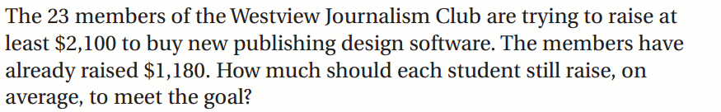variable _________________________________   
  
Inequality_________________________________ Solution set________________________________

Answer phrase______________________________

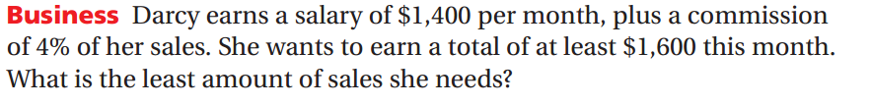

variable _________________________________   
  
Inequality_________________________________ Solution set________________________________

Answer phrase______________________________